

App Server

IWA

IWA

App Server



IWA

App Server



App Server

IWA



IWA

App Server

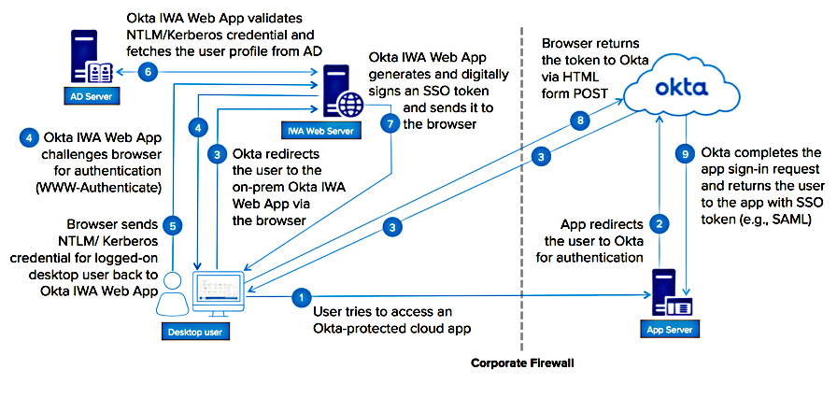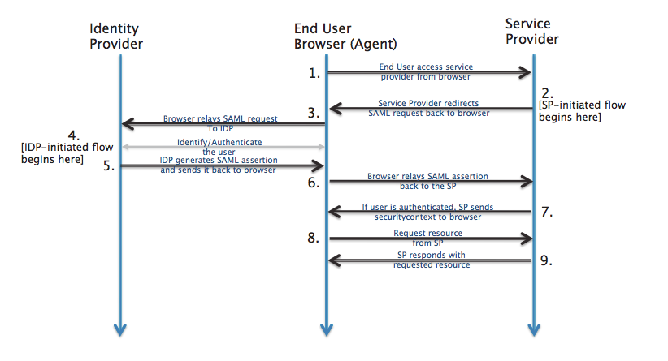

<https://help.okta.com/en/prod/Content/Topics/Directory/Configuring_Desktop_SSO.htm>

<http://developer.okta.com/standards/SAML/>